Part 4
Games and Teaching Aids

“Word Search” on Hope
How to Play:
Search for the words related to “Hope” in the word search puzzle.

HOPE

X | R | O | C | P | O | S | I | T | I | V | I | T | Y
T | D | P | Y | U | Z | L | F | Y | X | G | R | I | T
Q | H | T | G | D | S | I | H | O | P | E | F | U | L
Z | B | I | H | R | E | P | K | R | E | Y | J | Z | D
A | C | M | F | E | G | L | G | A | R | D | G | T | K
S | N | I | K | A | R | O | W | D | S | G | F | D | I
P | O | S | K | M | J | V | H | W | E | Q | E | A | N
I | J | M | P | G | O | E | A | I | V | C | N | W | D
R | T | L | A | S | D | C | Z | Q | E | B | E | T | N
A | W | B | E | L | I | E | F | G | R | M | R | U | E
T | S | Q | K | I | G | J | D | S | A | Z | G | H | S
I | B | J | N | G | O | A | L | J | N | F | Y | R | S
O | K | O | M | H | X | W | A | H | C | J | S | H | J
N | D | Y | E | T | H | S | T | R | E | N | G | T | H

JOY | GOAL | GRIT | LOVE | DREAM
LIGHT | ENERGY | BELIEF | HOPEFUL | KINDNESS
OPTIMISM | STRENGTH | ASPIRATION | POSITIVITY | PERSEVERANCE

A Cootie Catcher on Hope
How to Play:
    - In groups, ask students to write “Hope Challenges” (e.g. share an English saying of wisdom on “Hope”) inside the eight small triangles in the cootie catcher template below.
    - Fold the cootie catcher (see instructions on p.58).
    - In groups, students take turns to choose a shape and a number (e.g. heart shape, 5). Open and close the cootie catcher while counting out the number picked.
    - Complete the task shown on the flap of the shape picked.

A Sample Cootie Catcher on Hope

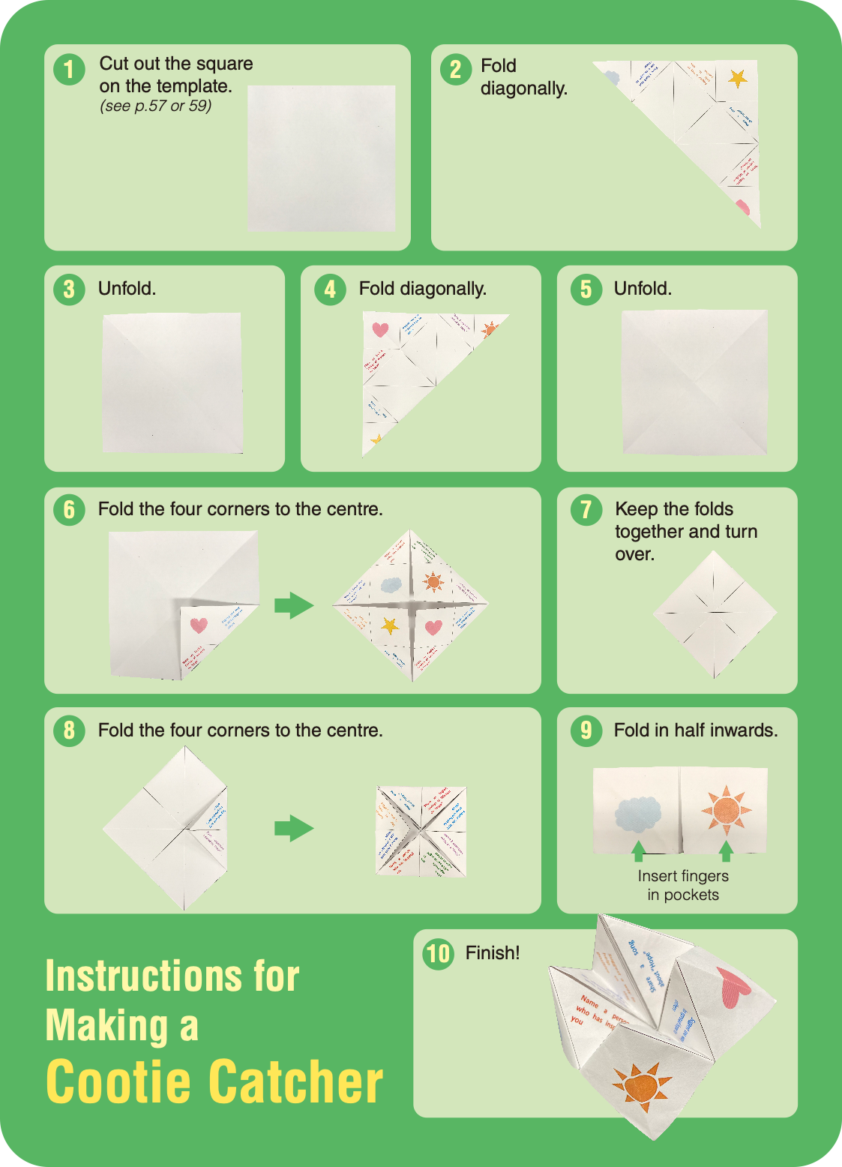
(see p.59)

Design Your Own Cootie Catcher!

Card Game on Hope

Activity Description
This card game is a collection of words, ideas and sayings revolving around positive values and attitudes. The game comprises 40 different cards that encourage teachers and students to unlock their creativity and invent their own ways to play the game to develop their language skills and learn more about positive values and attitudes.

List of Words on the Cards:
 | 22 | Believe
 | 23 | Plan
 | 24 | Prioritise
 | 25 | Be organised
 | 26 | Make choices
 | 27 | Set goals
How to instil hope in others’ life | 28 | Love
 | 29 | Sharing
 | 30 | Companionship
 | 31 | Support
 | 32 | Cooperation
 | 33 | Caring
 | 34 | Be a good listener
 | 35 | Encouragement
Sayings | 36 | Fall seven times, stand up eight.
 | 37 | Count your blessings.
 | 38 | When life gives you lemon, make lemonade.
 | 39 | Where there’s a will, there’s a way.
 | 40 | Have faith in yourself.

Personality  /Attitude | 1 | Stay hopeful
 | 2 | Never give up
 | 3 | Gratitude
 | 4 | Grit
 | 5 | Perseverance
 | 6 | Optimism
 | 7 | Be proactive
 | 8 | Confidence
 | 9 | Ambition
 | 10 | Eagerness
 | 11 | Determination
 | 12 | Be tough
Tips on achieving  your goals  (How to  stay  hopeful in  life to  achieve  your goals) | 13 | Cherish what you have
 | 14 | Appreciate others
 | 15 | Aspire
 | 16 | Dream
 | 17 | Grab your
 |  | opportunity
 | 18 | Smile
 | 19 | Learn from mistakes
 | 20 | Stay motivated
 | 21 | Try again

Below are some of the suggested games:

Game |  | How to Play
1 | Be a Storyteller | For individual players:  Each player picks a card/a few cards and tells a story with a positive message based on the word(s) picked.  For groups:  In groups, each player picks four cards and creates a story using the words. Have a vote in the group to decide on different awards (e.g. the most creative story, the most interesting plot, the most meaningful message) after listening to each other’s story.
2 | Create an Alliterative Slogan | Players select the cards with single words only. In groups or individually, they create a short slogan with positive meaning using alliteration.  (e.g. Word picked: Love  Slogan: Live, Laugh, Love every day.)
3 | Synonyms and Antonyms | Players select the cards with single words only. In groups or individually, they say the synonyms/antonyms of the word on the card picked. The fastest one wins.
4 | King of “Part of Speech” | Players select the cards with single words only. In groups or individually, they name the part of speech of the word on the card picked. The fastest one wins.
5 | Impromptu Speech | Players select a card and give a one-minute impromptu speech based on the word(s). Vote for the most creative/inspiring speech presented.
6 | Guess the Meaning | A player picks the card and mimes the word shown on the card. Other players guess the meaning.
7 | Freeze Frame Challenge | Play the game in groups. Place all the cards on the table with the words facing down. Send a group representative to pick a card. In one minute, the group which picks the card works together, designs a freeze frame and performs their freeze frame. Other groups guess the word(s) on the card.

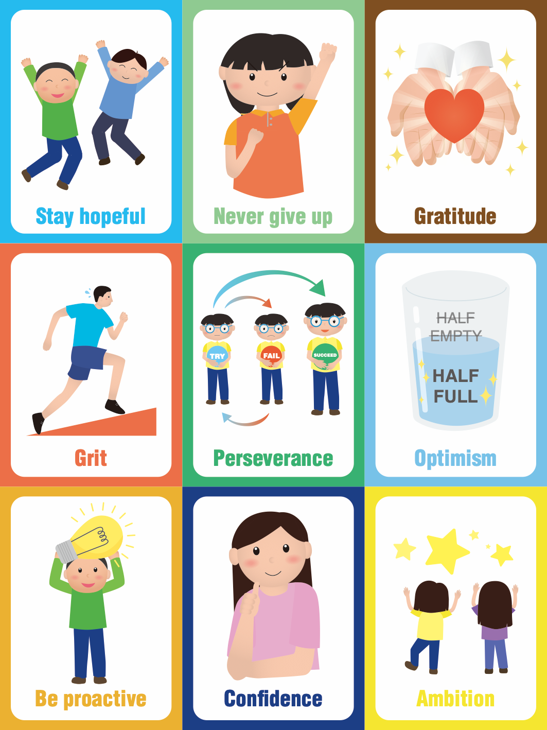

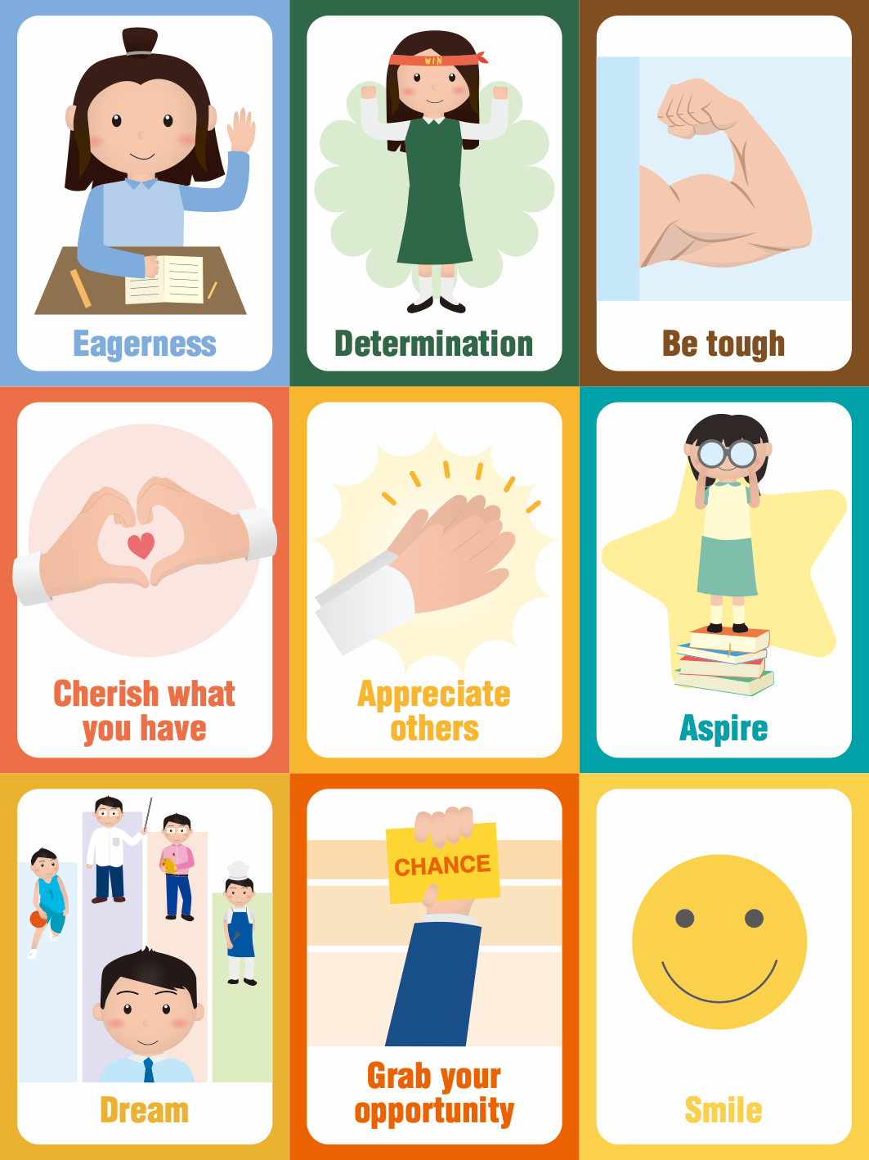

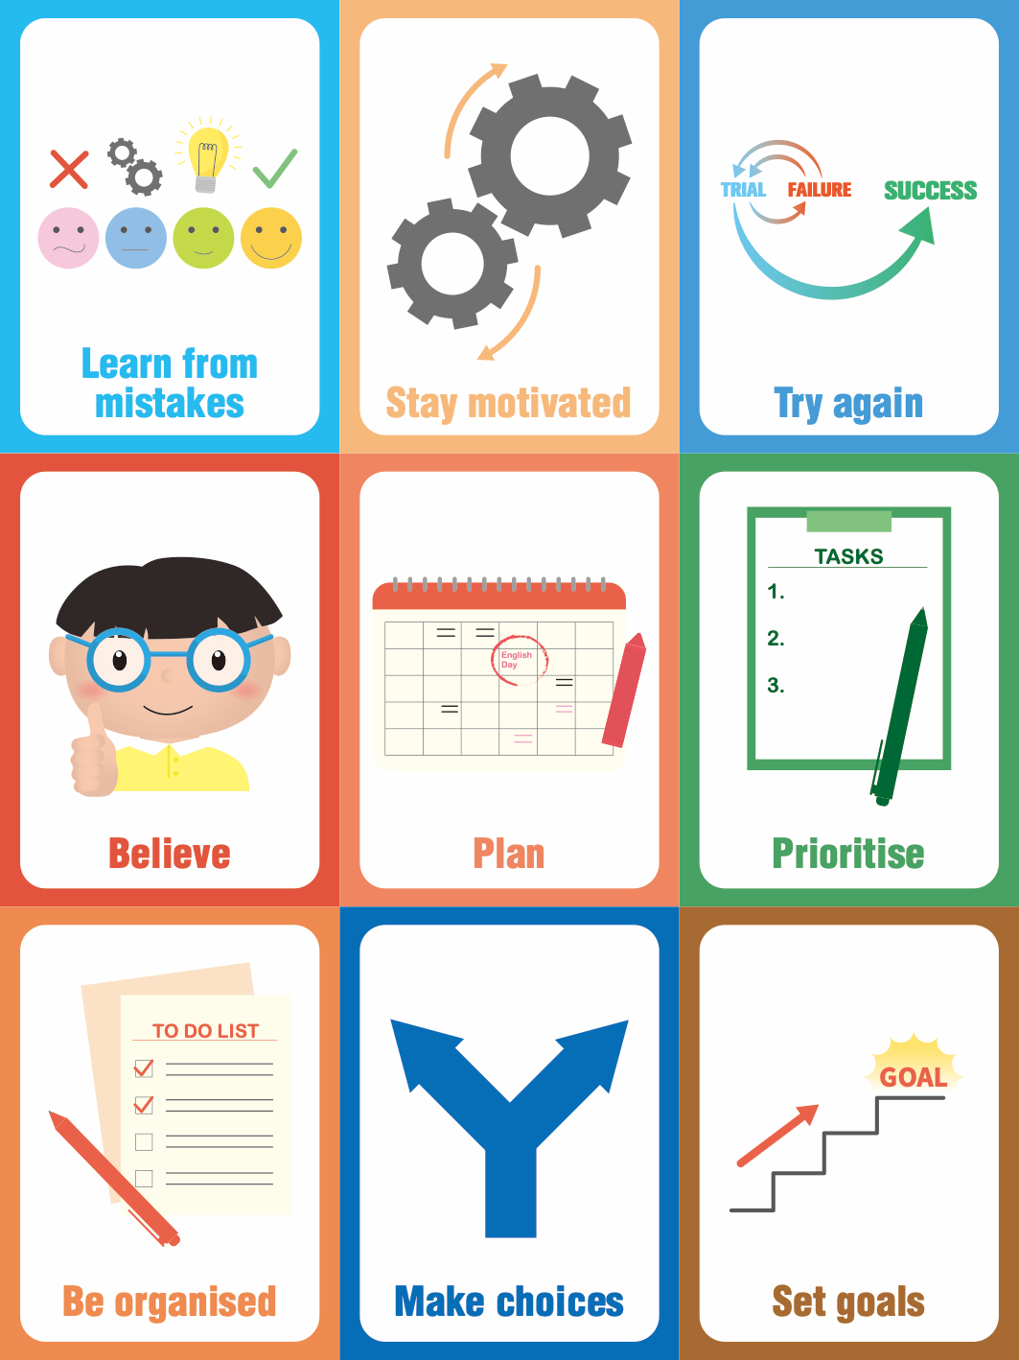

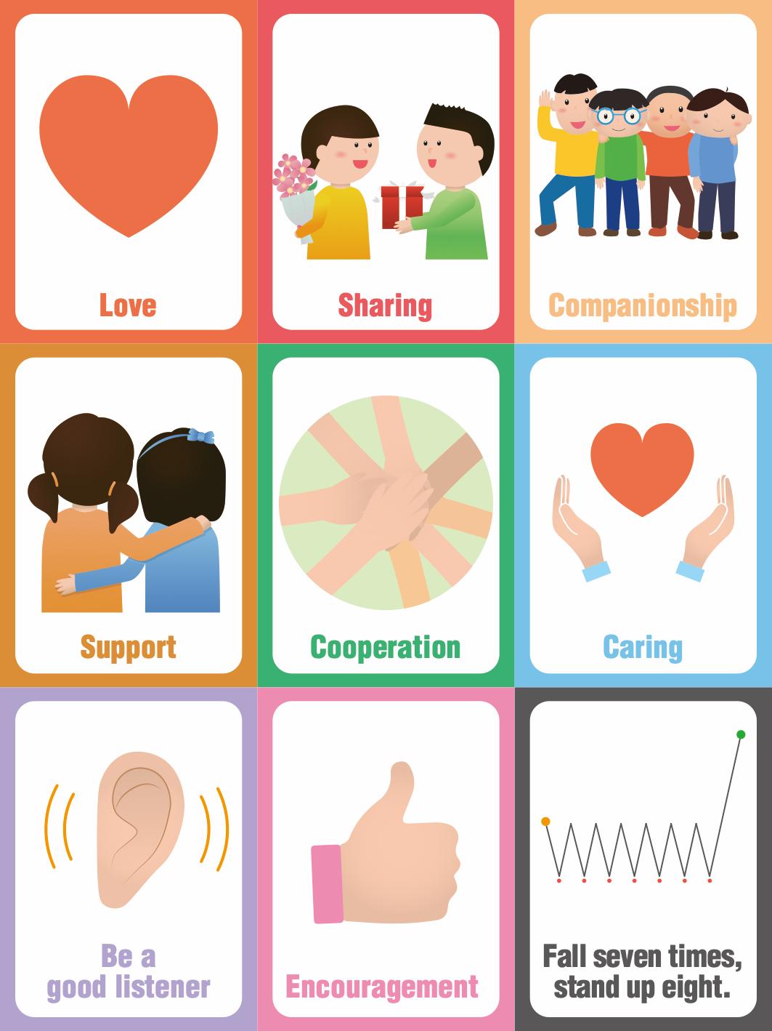

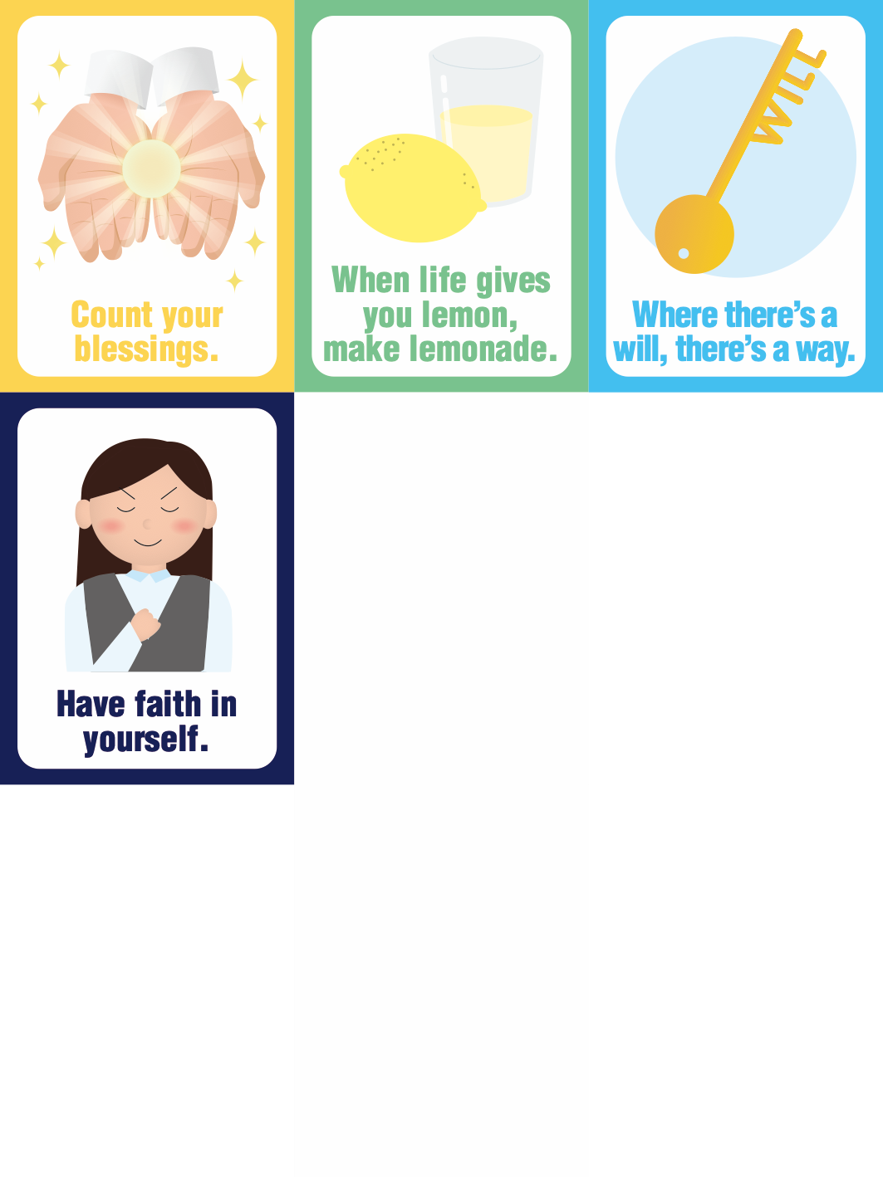

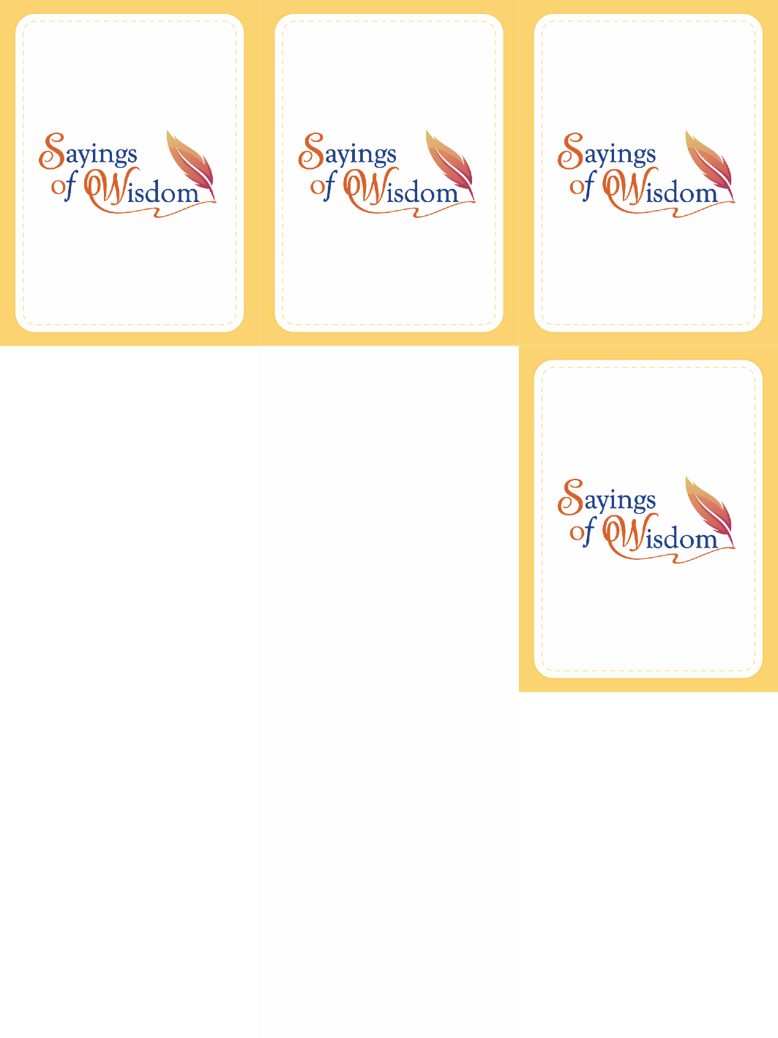

4.4 Hope Challenge
Invite the class to take part in the “Hope Challenge”. Set a time period for them and encourage them to complete as many “Hope Challenges” as possible. Get them to share the most memorable experience afterwards.

Engage other stakeholders in the challenge. Get students to invite the people around them to join them (e.g. the principal, teachers, parents, siblings, neighbours). Let them modify or add other challenges.

HOPE CHALLENGE
Do something that makes your friend smile. | Recommend a book about hope to someone. | Sing a song  about hope.
Write a note of encouragement to your classmate. | Take part in a voluntary service. | Create a slogan about hope.
Create an  artwork which  displays a  positive  message. | Cheer up  someone who  feels down. | Share an inspirational quote with a friend.

A–Z List of Adjectives to Describe

People with Positive Values and Attitudes
In groups or individually, students write an A–Z list of adjectives to describe people who possess positive values and attitudes. Challenge students by setting a time limit for the game.

A–Z list on

